Subnet Mask
# Source: Chatgpt (GPT-5-Mini) at [1/18/2026]
A subnet mask is a 32-bit number used to divide an IP address into two parts:
- Network portion – Identifies the network
- Host portion – Identifies the specific device (host) on that network
It helps routers determine which part of the IP is for routing and which part is for identifying individual devices.

🧾 Simple Definition:
# Source: Chatgpt (GPT-5-Mini) at [1/18/2026]
A subnet mask tells the router where the network ends and the host begins in an IP address.

🧮 Common Subnet Masks and CIDR Equivalents:
# Source: Chatgpt (GPT-5-Mini) at [1/18/2026]
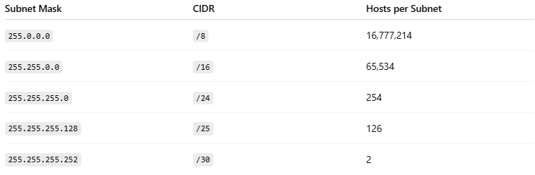

Subnet Mask | CIDR | Hosts per Subnet
255.0.0.0 | /8 | 16,777,214
255.255.0.0 | /16 | 65,534
255.255.255.0 | /24 | 254
255.255.255.128 | /25 | 126
255.255.255.252 | /30 | 2
🧮 Formula: Number of Hosts = 2ⁿ - 2 (where n = number of host bits)

🧱 Example:
# Source: Chatgpt (GPT-5-Mini) at [1/18/2026]
IP Address:
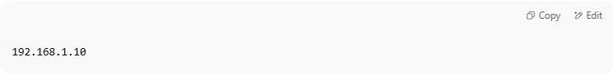
192.168.1.10

Subnet Mask:
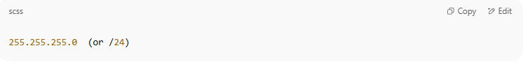
255.255.255.0 (or /24)

Breakdown in Binary:
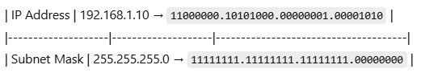
| IP Address | 192.168.1.10 → 11000000.10101000.00000001.00001010 |
|--------------------|--------------------|--------------------------------------|
| Subnet Mask | 255.255.255.0 → 11111111.11111111.11111111.00000000 |
- Network portion (first 24 bits): 192.168.1
- Host portion (last 8 bits): 10
So this device is in the 192.168.1.0/24 network.

🔄 Subnet Mask vs CIDR
# Source: Chatgpt (GPT-5-Mini) at [1/18/2026]
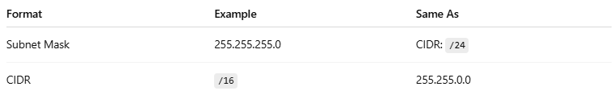
Format | Example | Same As
Subnet Mask | 255.255.255.0 | CIDR: /24
CIDR | /16 | 255.255.0.0
They represent the same concept — CIDR is a shorthand version.

✅ Summary
# Source: Chatgpt (GPT-5-Mini) at [1/18/2026]
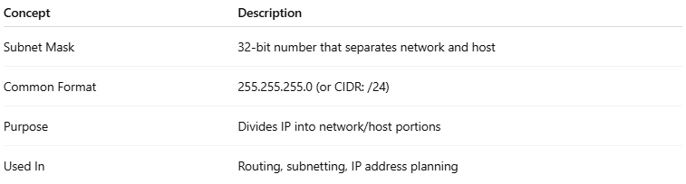

Concept | Description
Subnet Mask | 32-bit number that separates network and host
Common Format | 255.255.255.0 (or CIDR: /24)
Purpose | Divides IP into network/host portions
Used In | Routing, subnetting, IP address planning

